TASKS ON AUTO SCALING GROUPS

1. Create one VPC in N. Virginia region.

- Go to VPC service in the AWS platform, in the navigation pane select your vpcs and click on create VPC.
- Give the proper CIDR Range, so that we can do subnet masking perfectly.

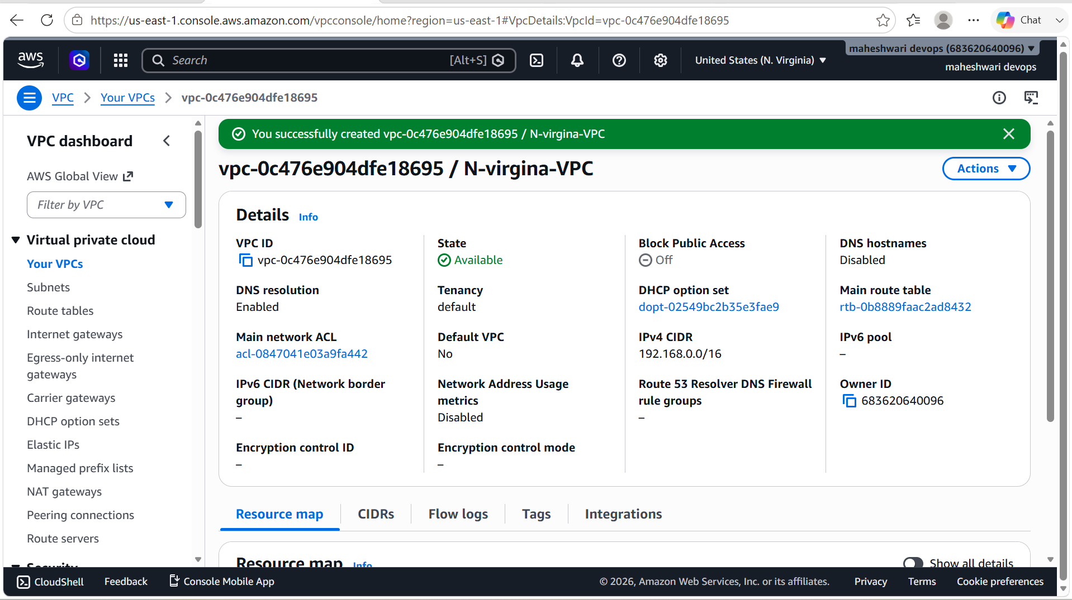

2. Create two subnets: one public subnet and one private subnet.
- We have to create 2 subnets for the VPC that we have created earlier.
- And the subnets should be one private and one public subnet.

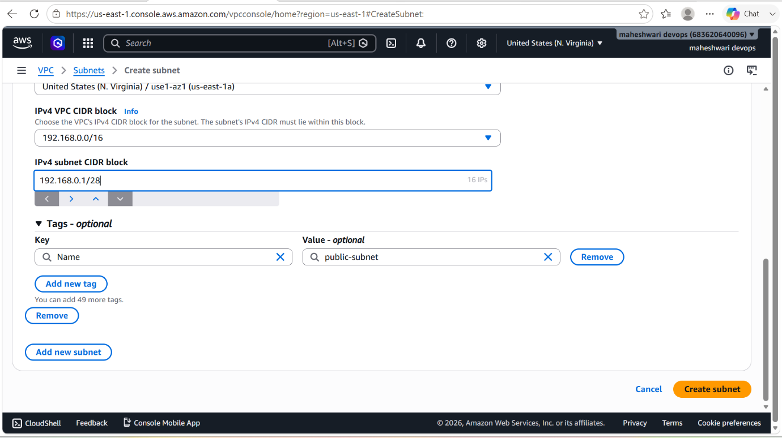

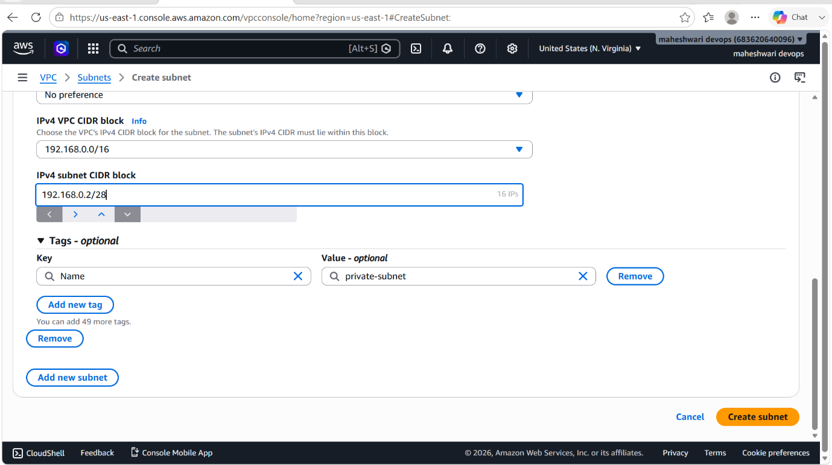

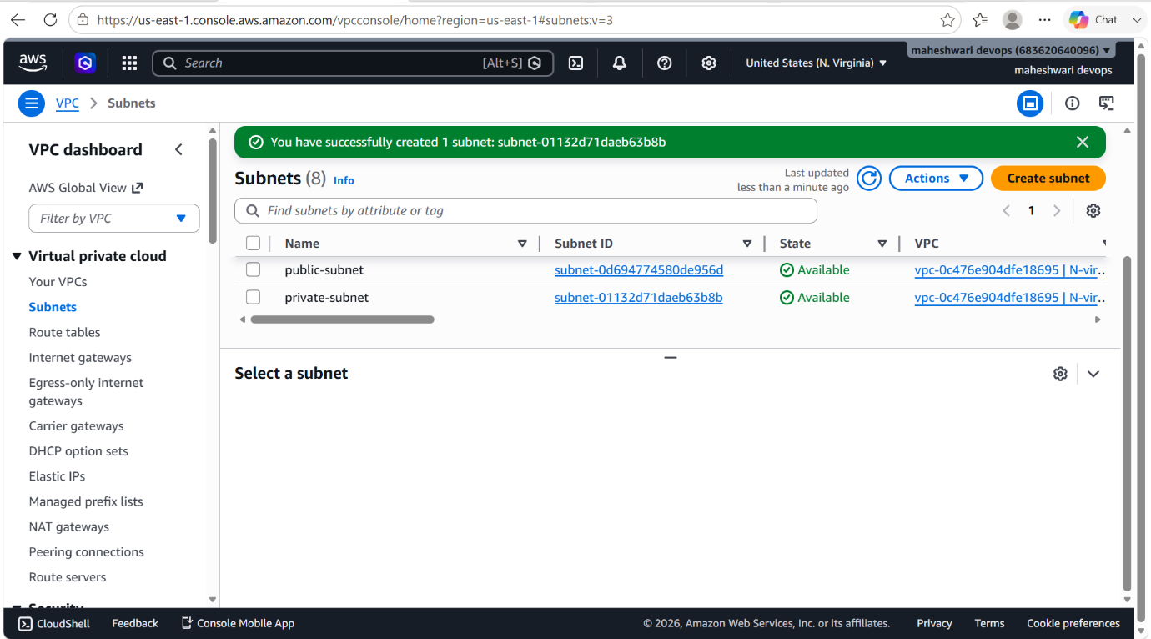

3. Attach an IGW to the VPC.
- In the navigation pane, go to internet Gateways and create a new internet gateway.
- Attach that created internet gateway to the VPC that we have created earlier.

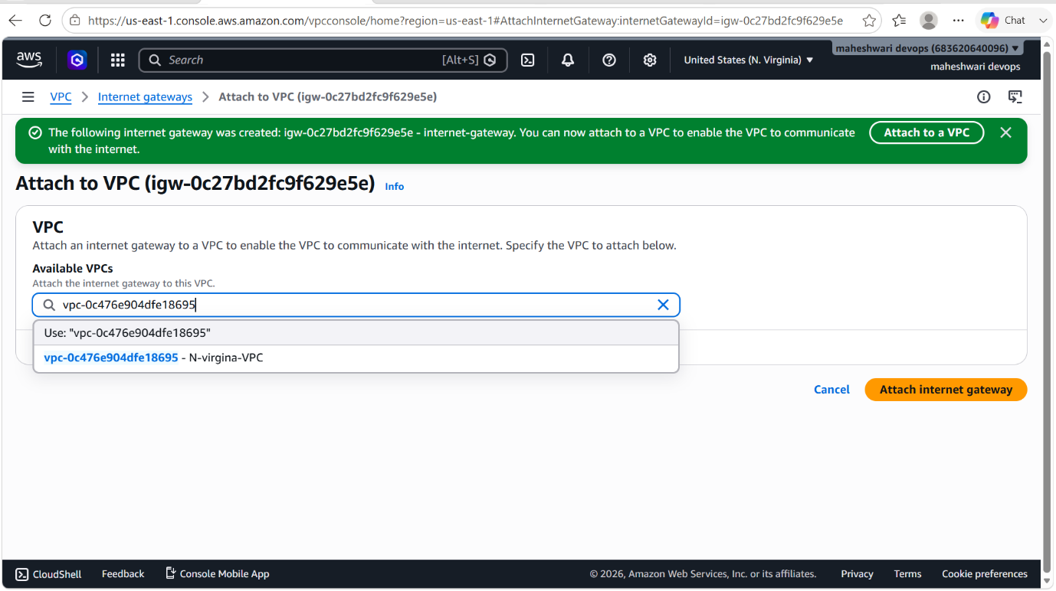

4. Create one public route table (RT) and one private route table.
- Create two route tables, one will be of public subnet associatedroute table and other one will of private subnet associated route table.
- Associate the subnets as of they are based on their route tables.

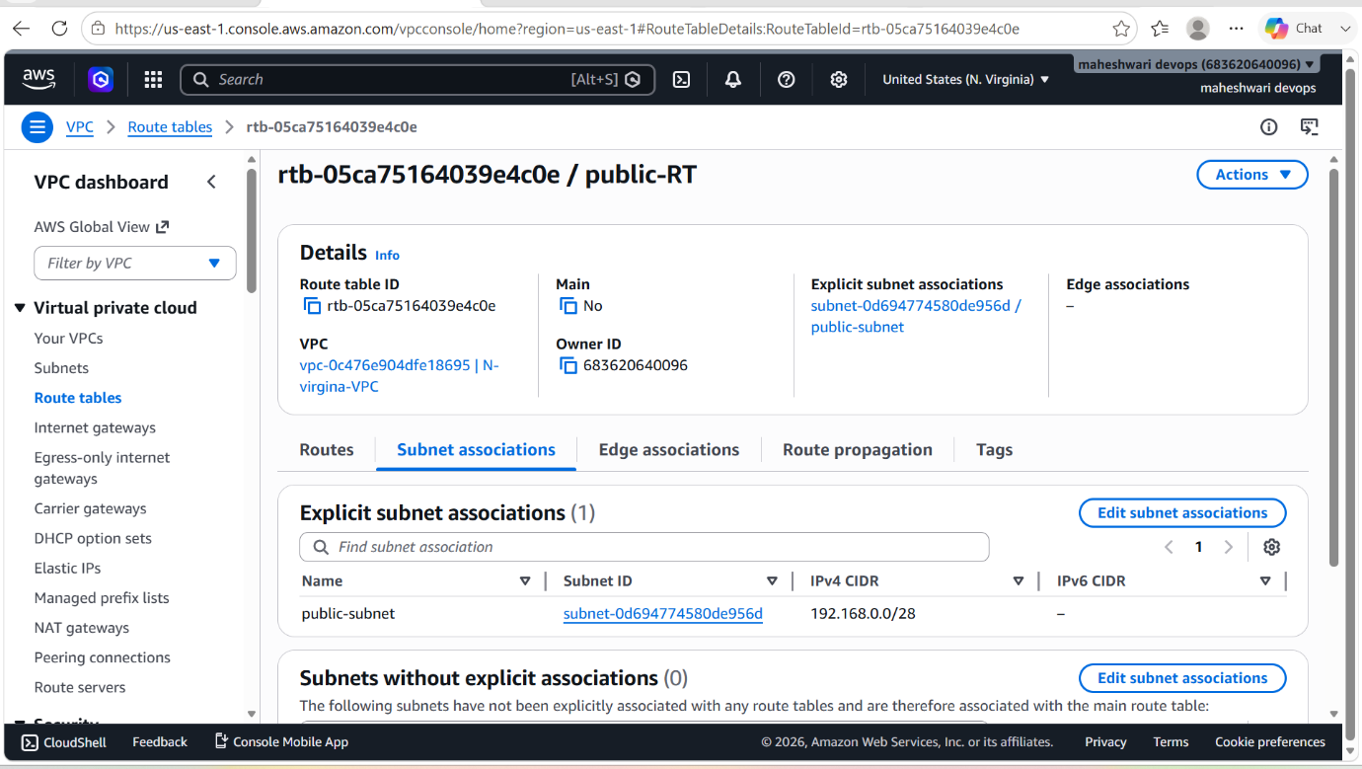

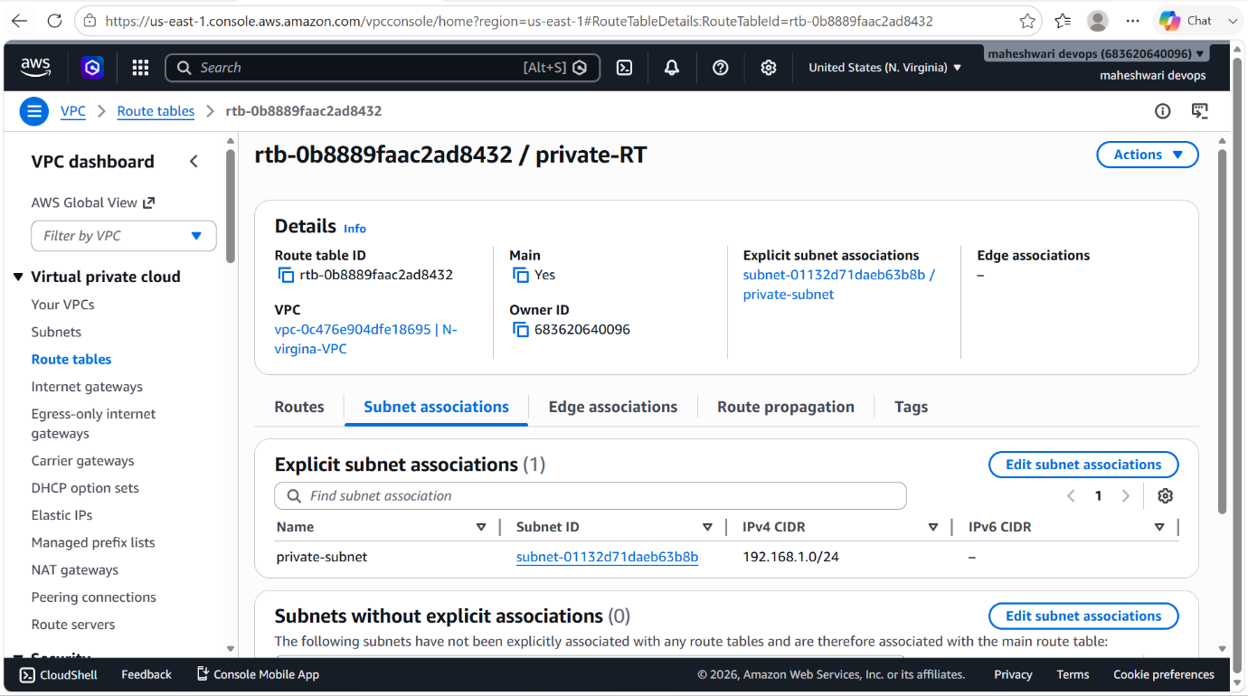

5. Deploy a NAT gateway in the public subnet and attach the NAT gateway to the private subnet.

- In the navigation pane of VPC, select nat gateways and create a new nat gateway to the VPC which is created earlier.
- Before this go to EC2 console, allocate elastic IP.
- That allocated elastic IP should attached to the subnet while creating NAT Gateway.
- After creating wait for sometime that pending should be available.

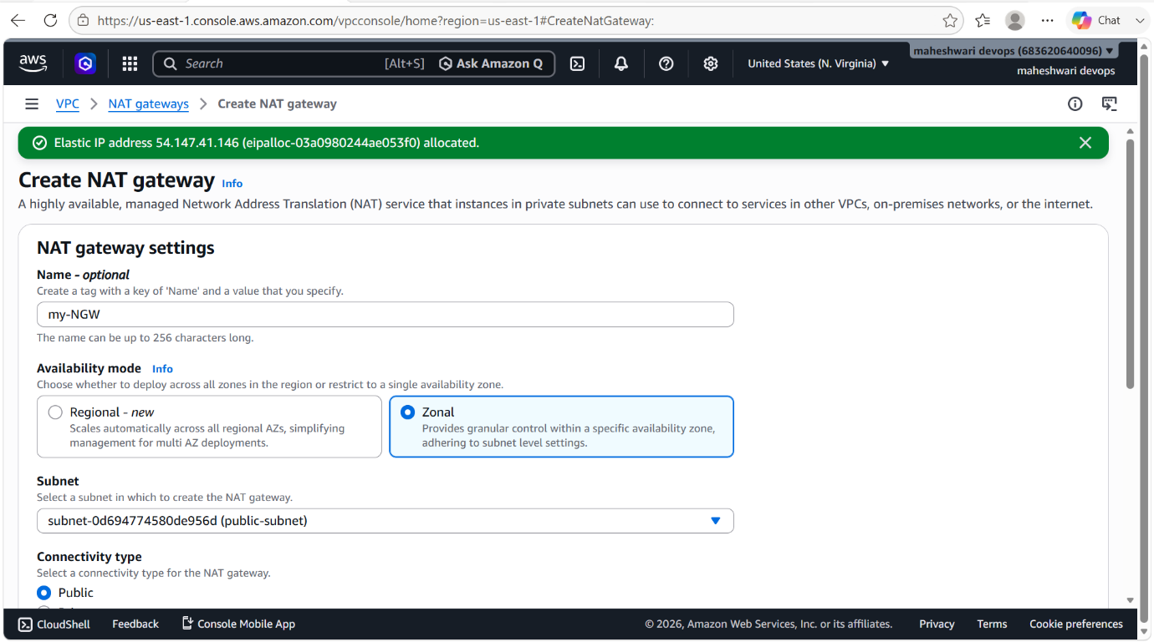

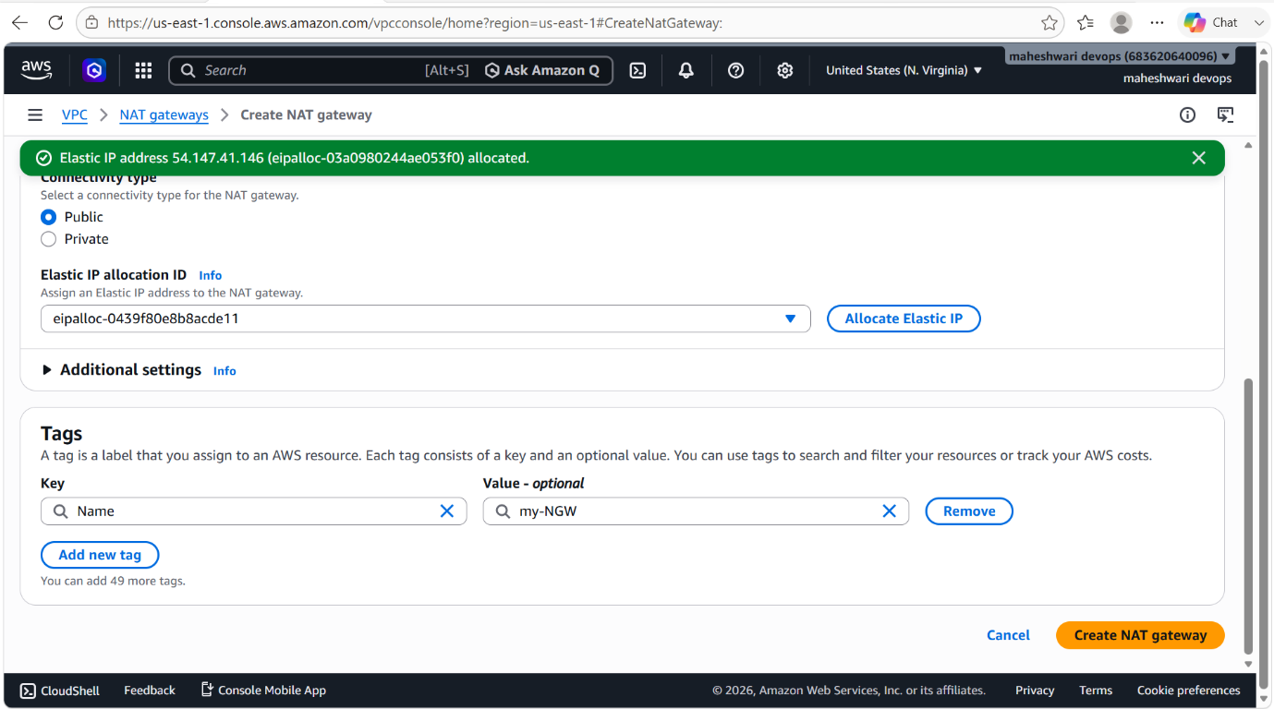

- And this created NAT gateway, add this gateway as a route in the private route table.
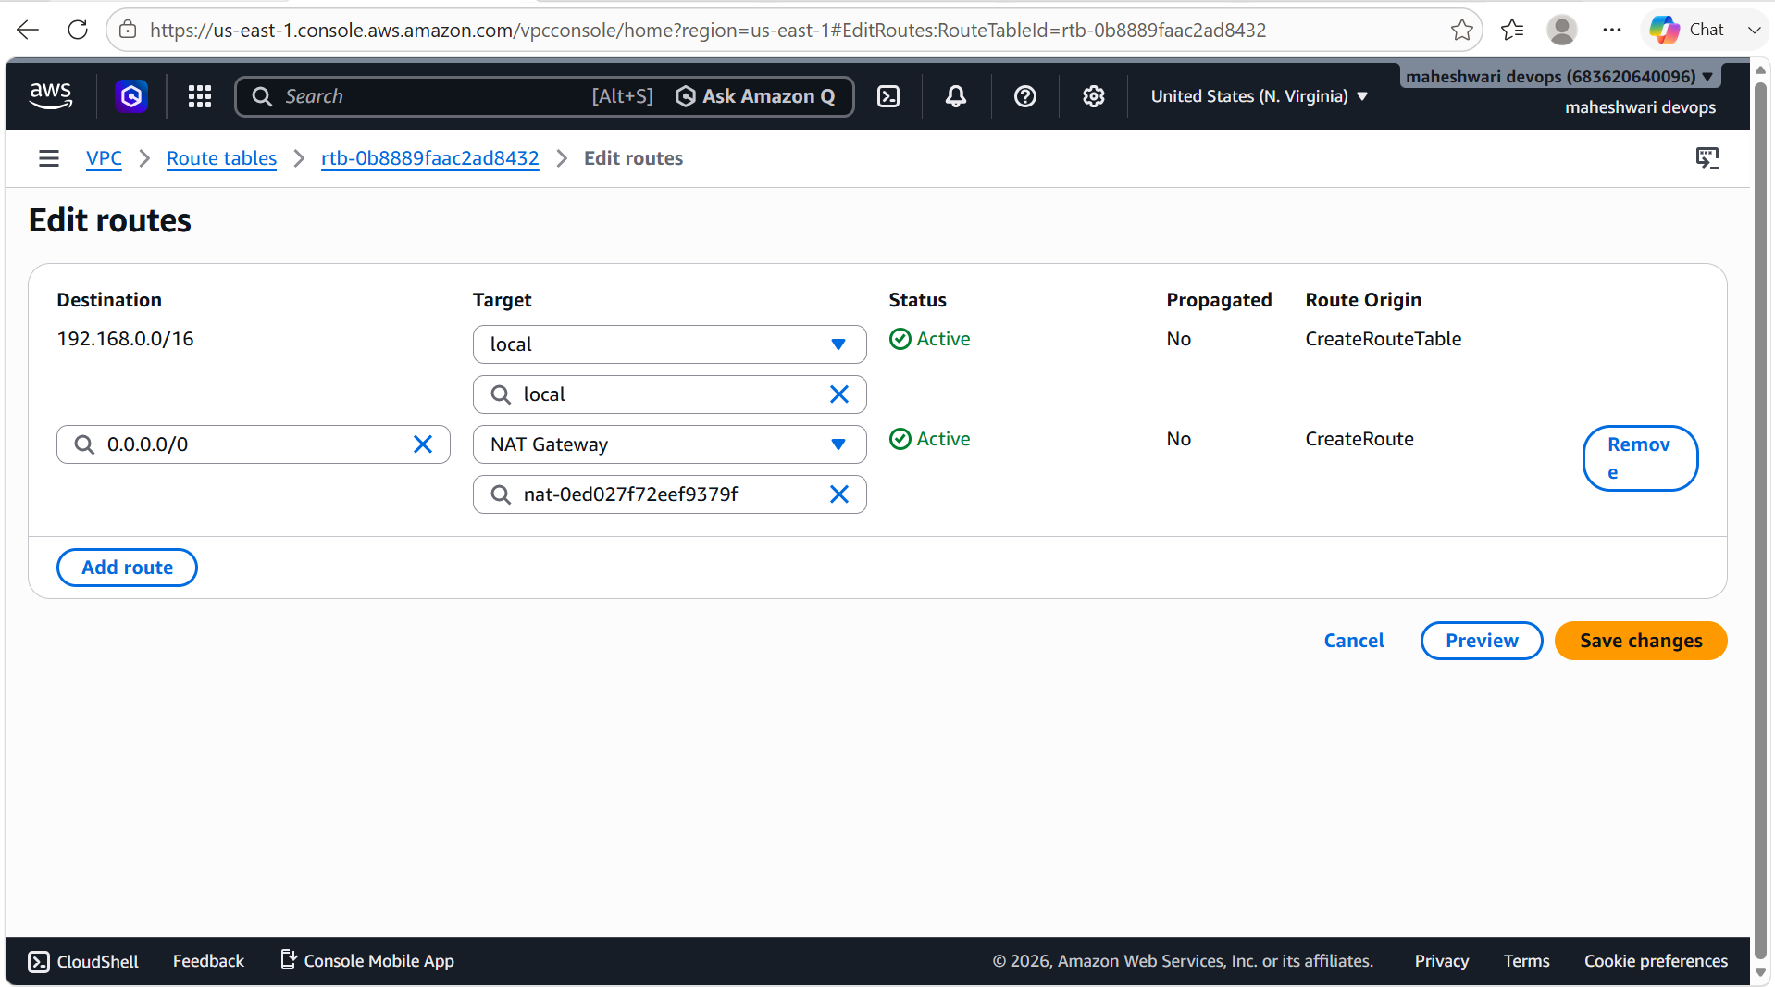

6. Create two instances, one in the public subnet and one in the private subnet.
- Created two instances, one instance is created in public subnet and other one is created in private subnet.
- From the instance which is in public subnet will acts as a bastion server or jump server and user for connect with the instance that is in private subnet.
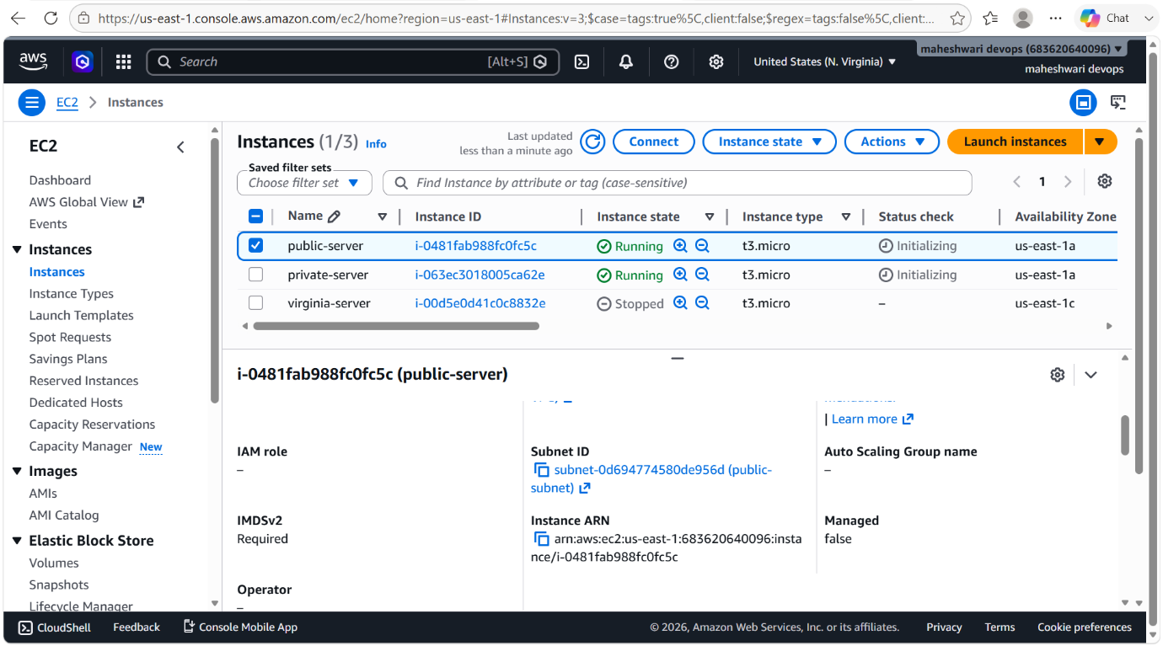
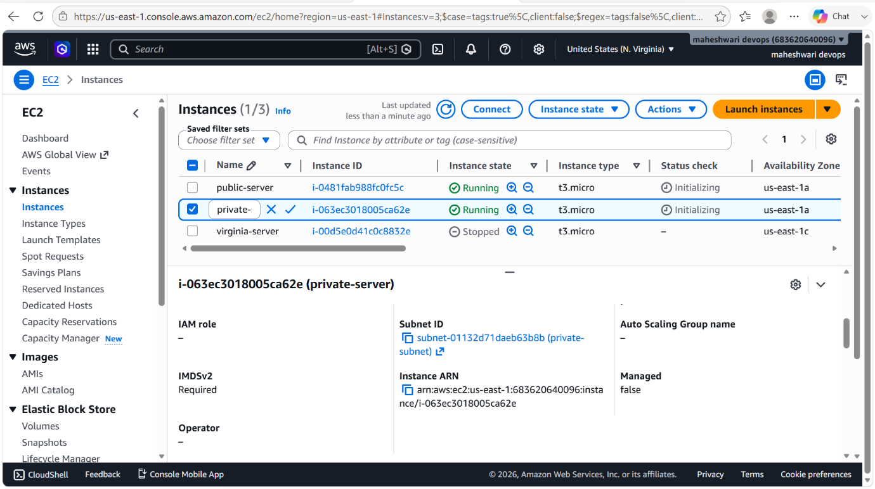

- We can check the connectivity with the ping command

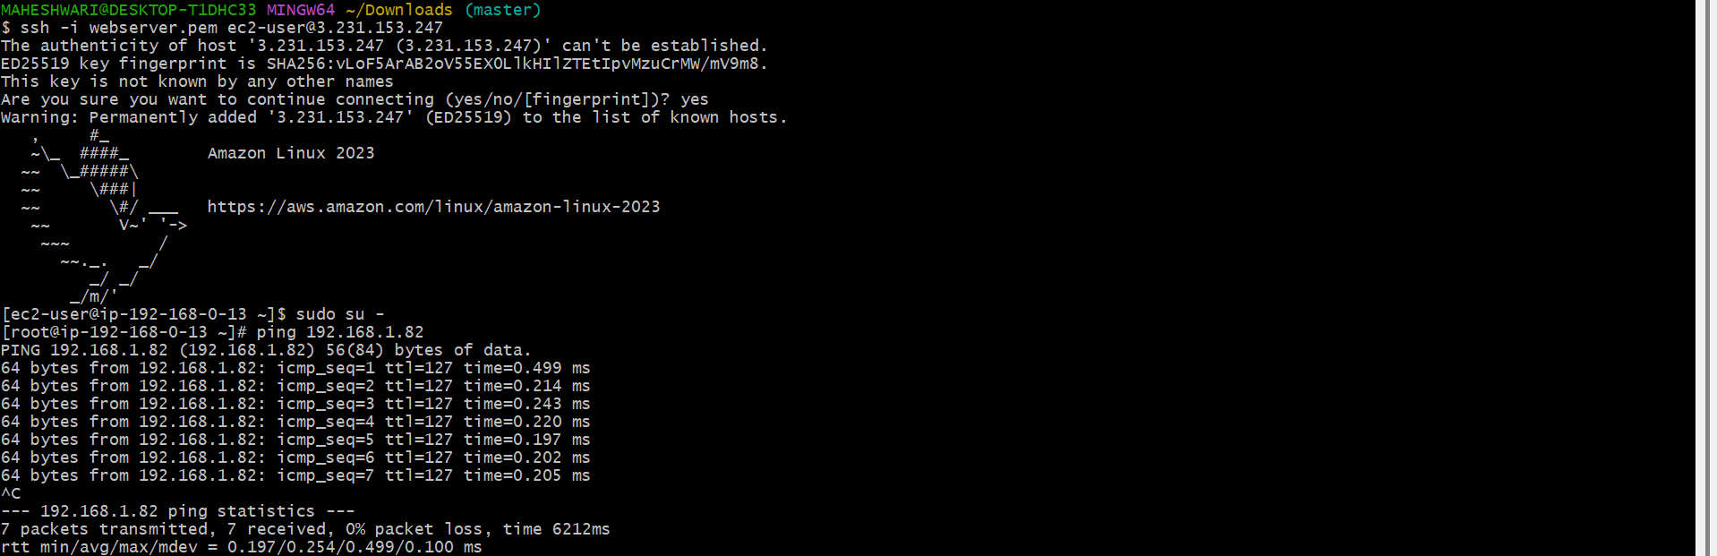

- To SSH into the instance which is in private subnet, we don’t have the pem key in the public instance.
- So for the SSH into the private instance we need the pem key. For that purpose we have create a file in the public instance and paste that pem key file content in that file in the public instance.
- By this process, we can connect to the private instance by using private IP.

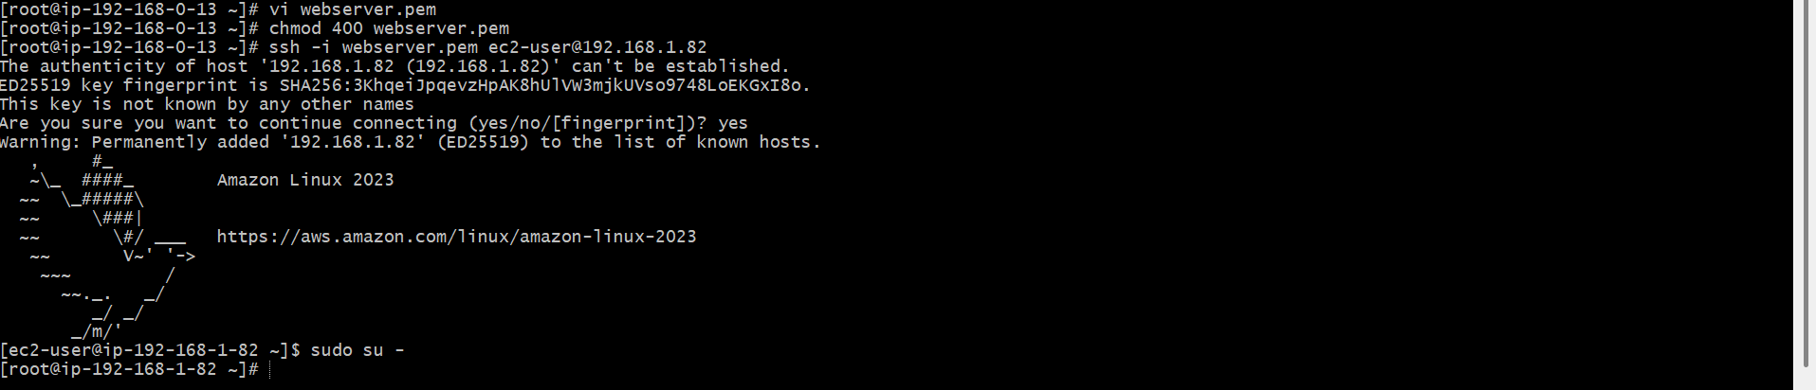

7. Deploy Apache server on both EC2 instances with a sample index.html file.

- We have download the apache httpd packages in both public and private instances.
- By using command yum install httpd.

PUBLIC-INSTANCE:

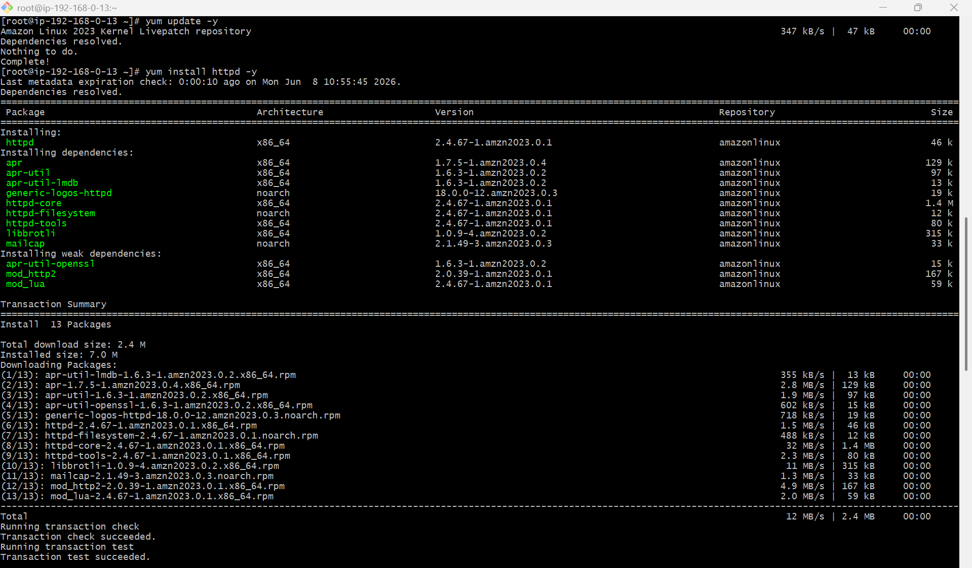

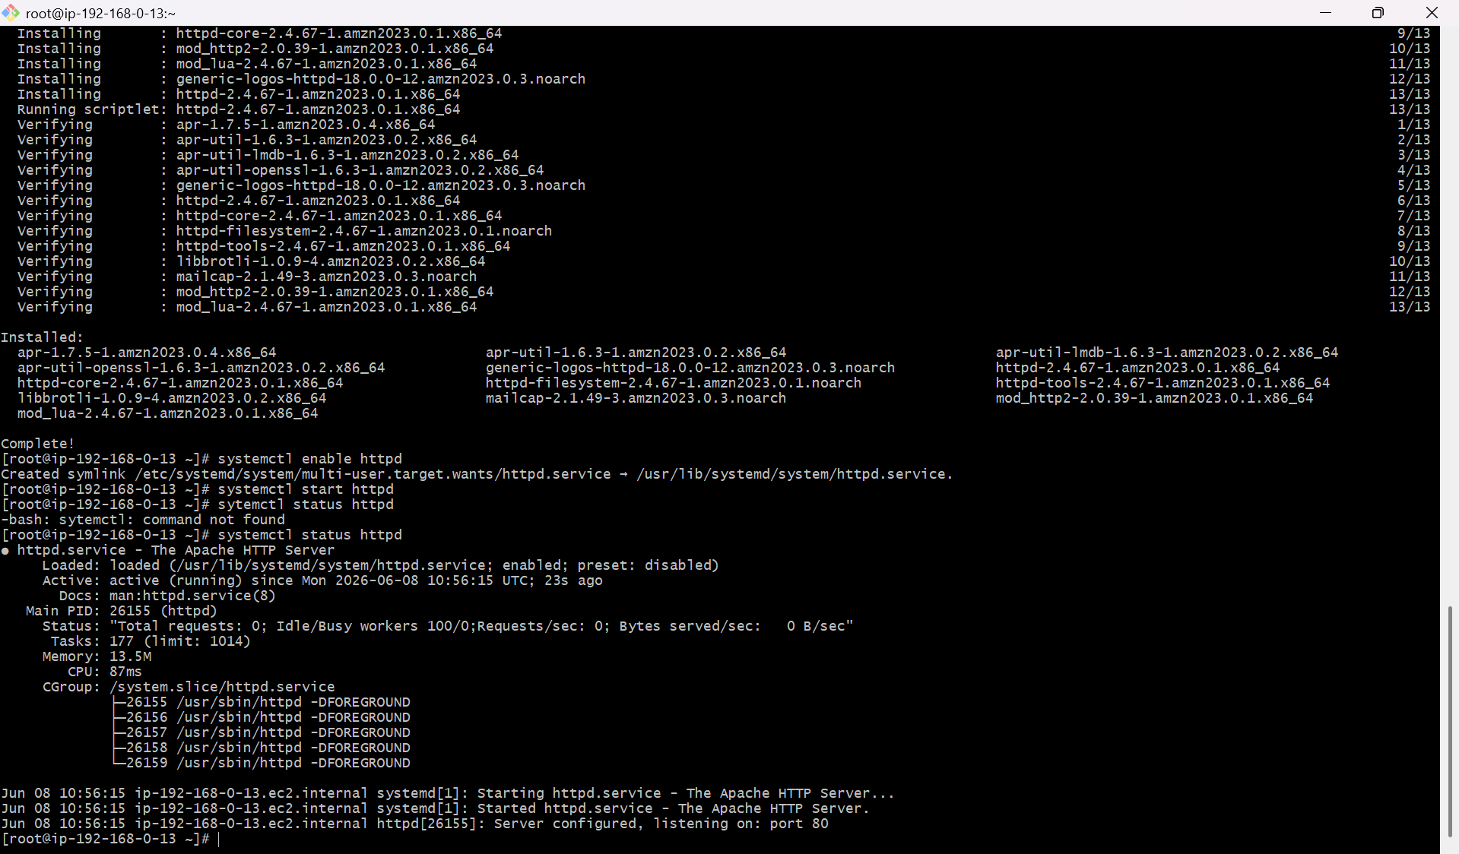

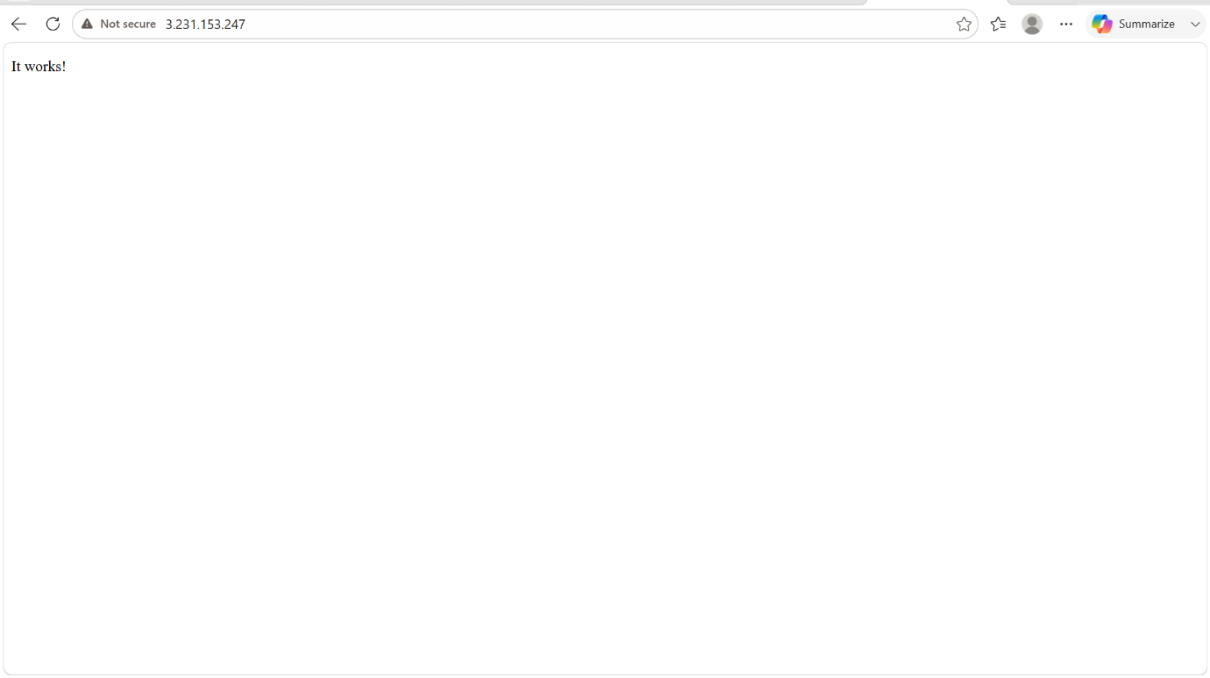

- To deploy our sample app in index.html file. This is the default deployment location for the httpd.
- This is the absolute location -> /usr/share/httpd/noindex/index.html

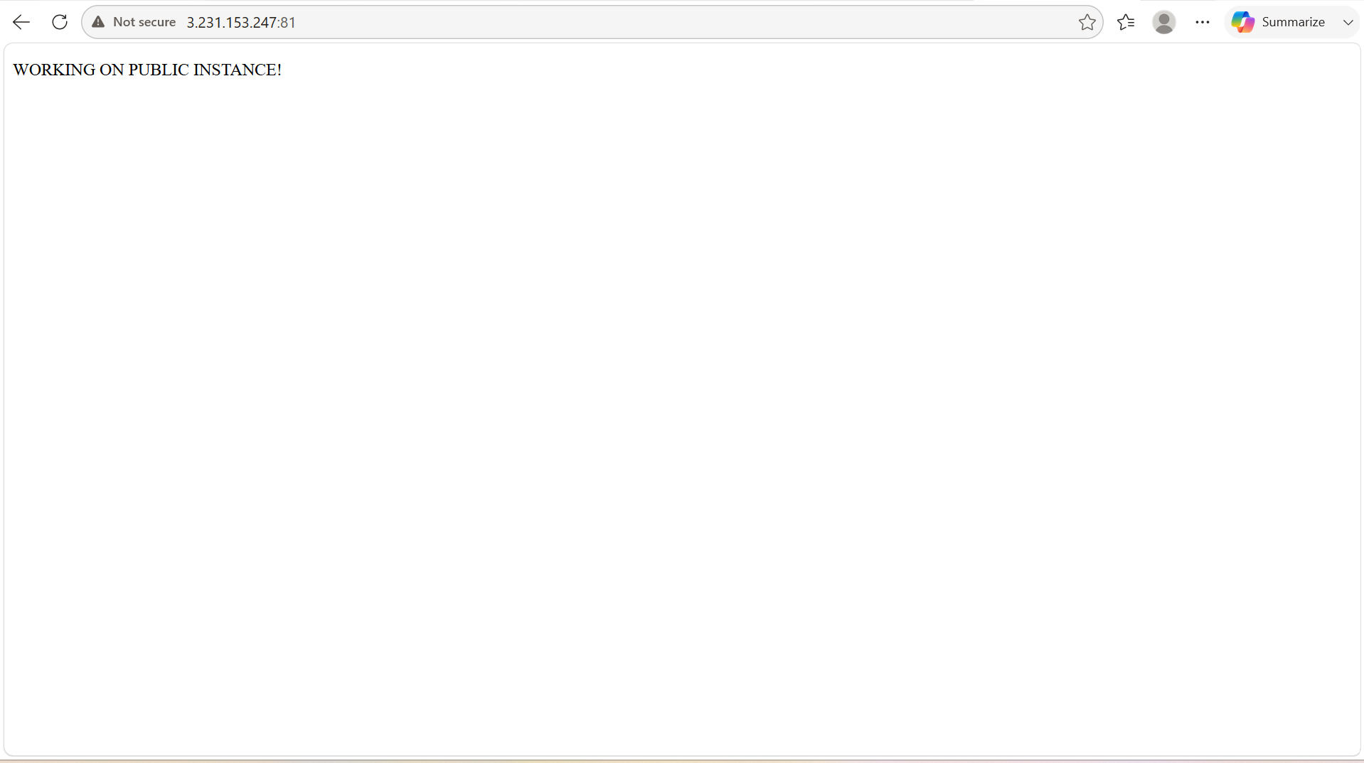

- We can also change the port number also by editing the /etc/httpd/conf/httpd.conf

PRIVATE INSTANCE:

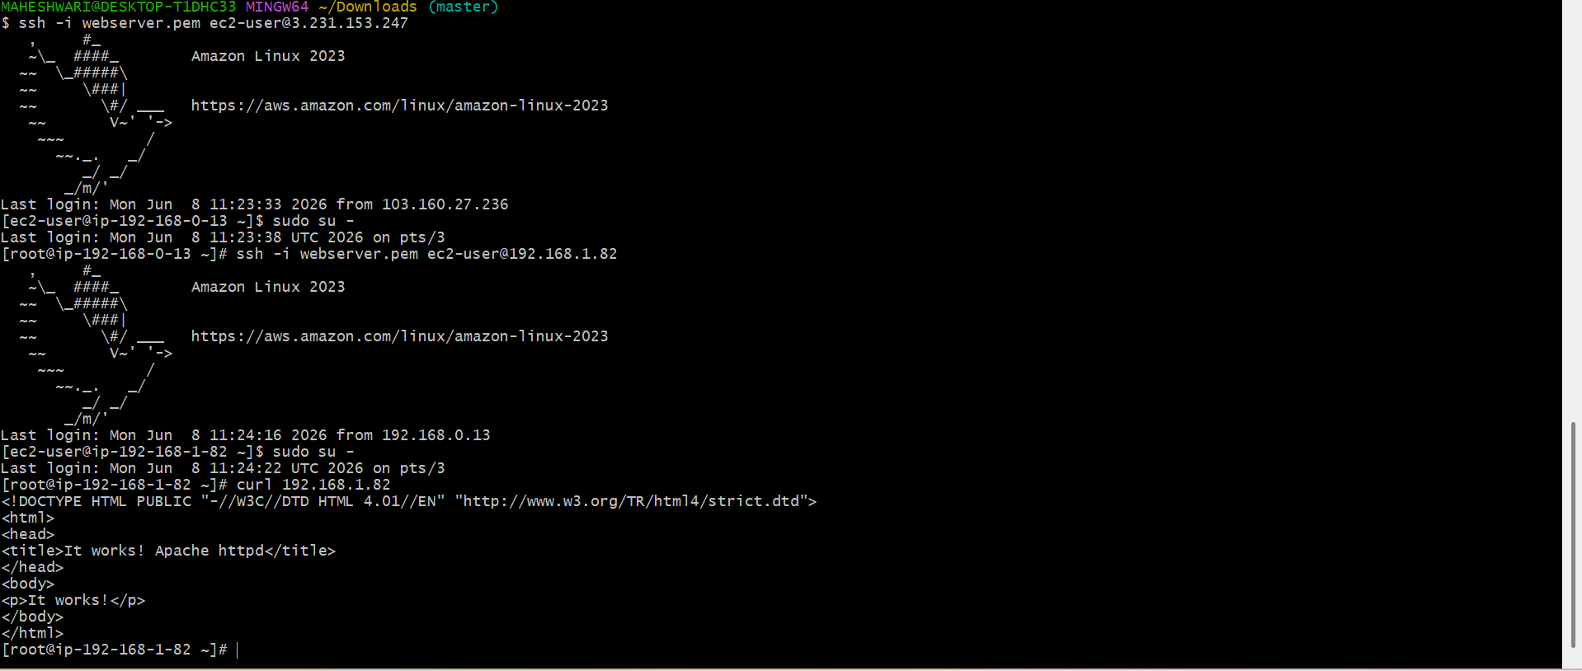
- After deploying sample index.html file.

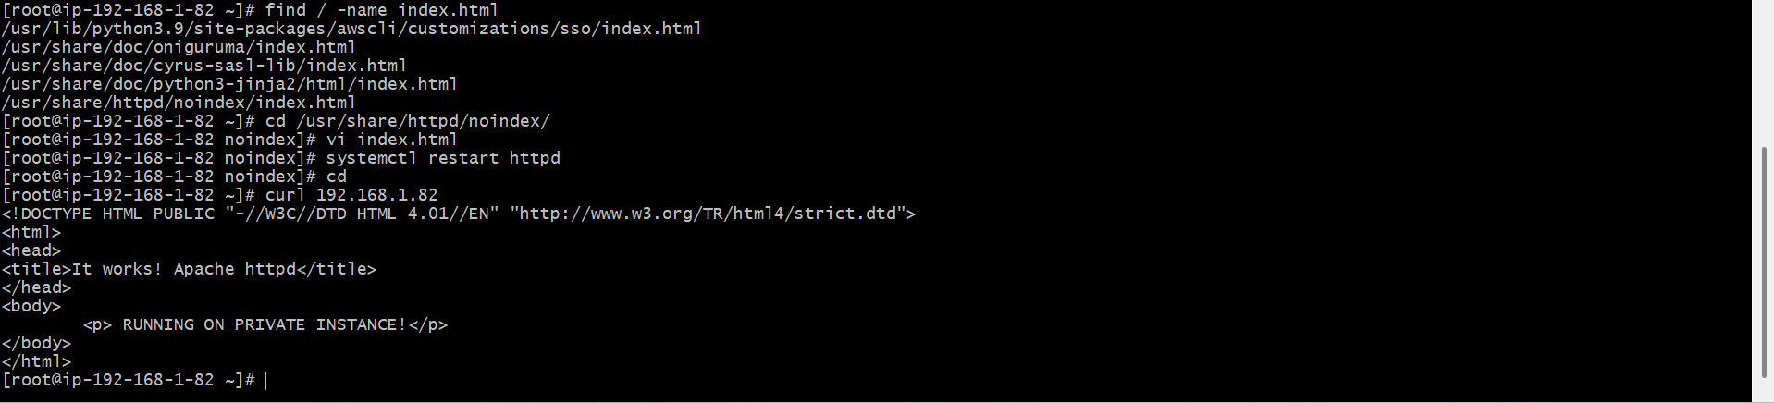

8. Create one application load balancer and attach it to both EC2 instances.

PURPOSE: To distribute incoming traffic across multiple EC2 instances, improving availability, fault tolerance and application performance.

OBJECTIVE: create an application load balancer (ALB), register both EC2 instances in a target group, and configure th ALB to route HTTP/HTTPS traffic to the instances.

PREREQUISITES:
- Two running EC2 instances.
- EC2 instances are in the same VPC.
- A security group allowing HTTP (80) or HTTPS (443) traffic.
- Web server (HTTPD, Nginx, Tomcat, etc.) running on both instances.
- Appropriate subnet configuration (at least two Availability Zones for the ALB).

STEP BY STEP IMPLEMENTATION:
- In the navigation pane of EC2 service, select target groups to create target group.
- In target group, add the two instances that we have created earlier.
- In target group, we should configure the instance type, protocol HTTP, port 80, and select your VPC.
- And click on next and add two EC2 instances & click on include as pending and click on create target.

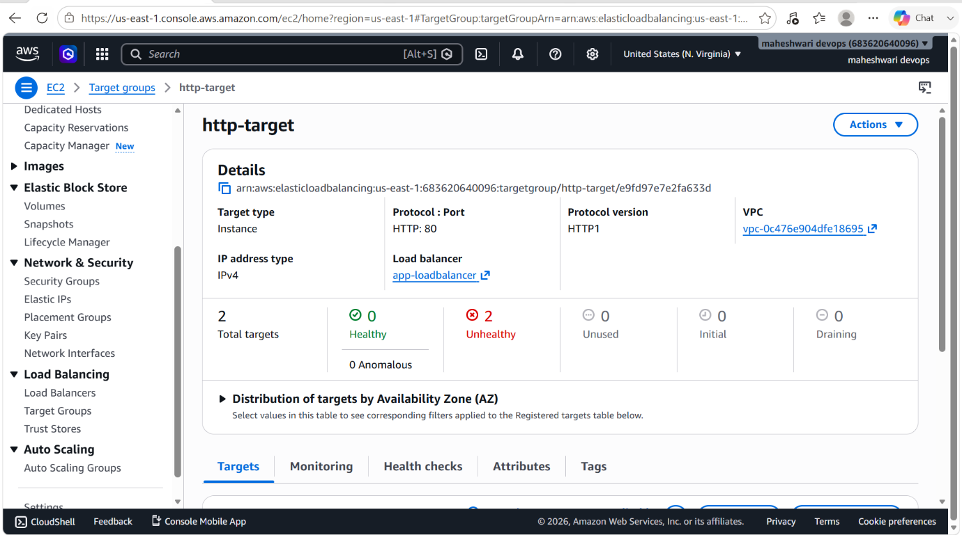
- In the navigation pane of EC2, click on load balancers.
- Now add a load balancer, in load balancer we should select application load balancer.
- Select internet-facing and select IPv4 address.
- Under network mapping select VPC and select atleast two subnets in two regions.
- Select security groups as HTTP 80 from 0.0.0.0/0.
- Under routing and listeners, listener 80 and select the target group.
- And click on create load balancer.
- Now load balancer will create URL and it will distribute the load between the servers that have attached to the target groups.
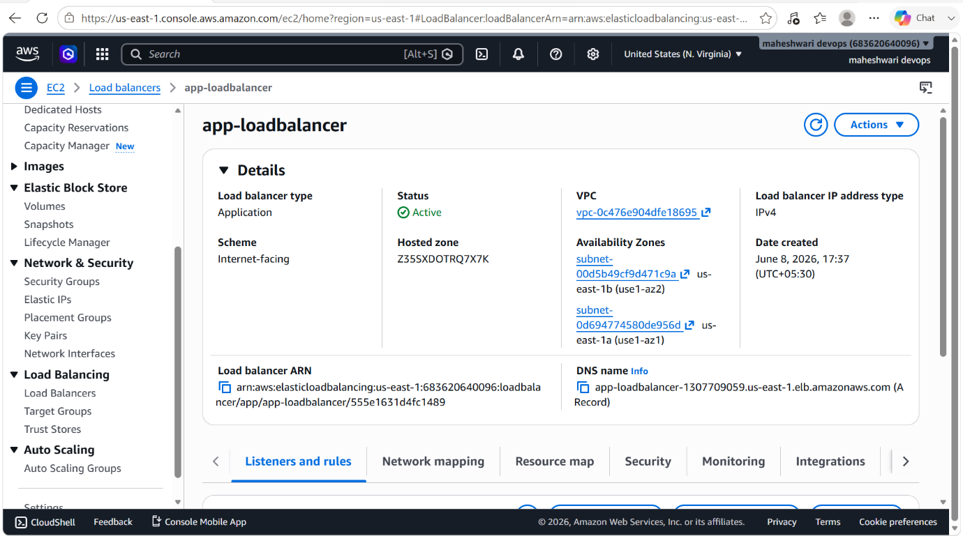
- To verify the load balancer, browse the load balancer URL that have created by load balancer.



9. Store application load balancer logs in S3.

PURPOSE: To capture and store Application Load Balancer access logs in an S3 bucket for auditing, troubleshooting, monitoring and traffic analysis.

OBJECTIVE: Enable access logging on the ALB and configure an S3 bucket to receive and store the log files.

OUTCOME:
  - ALB access logs are automatically delivered to S3.
  - Every request handled by the load balancer is recorded.
  - Logs can be used for troubleshooting, security audits, traffic analysis.

STEP BY STEP IMPLEMENTATION:
- Create a S3 bucket for logging the load balancer logs.
- Add a bucket policy for permissions to the bucket.
- These created bucket should attach to the ALB.
- In ALB, go to attributes and enable the access logs and to store that logs we should add the S3 bucket by adding that bucket.
- To verify that access logs, browse the server and check the logs in S3 bucket.

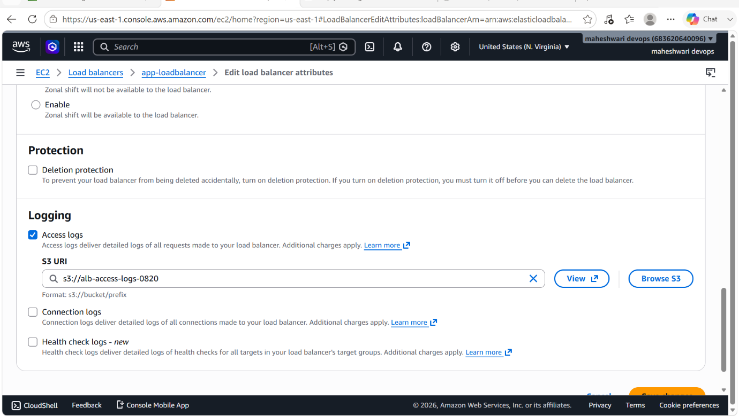

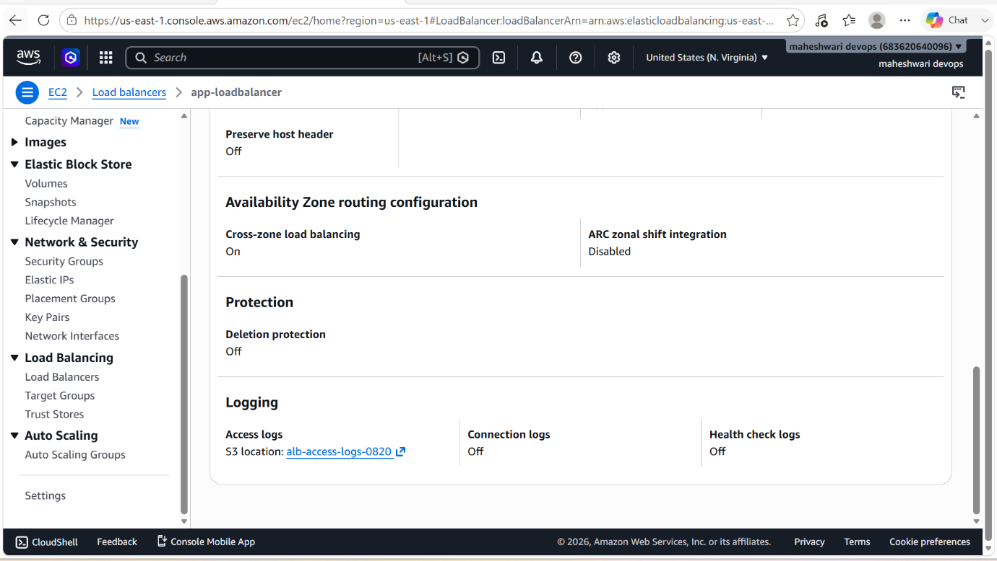

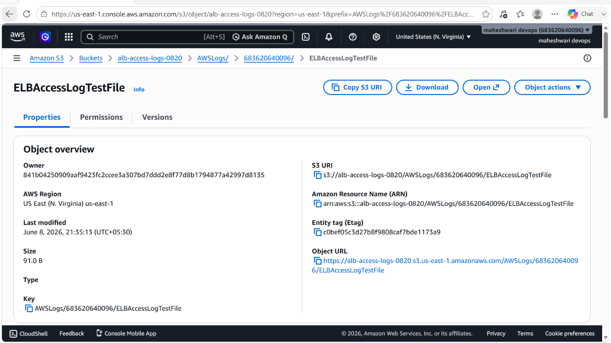

10. Store the VPC flow logs in a CloudWatch log group.

PURPOSE: To capture and monitor network traffic information flowing in and out of a VPC and store the logs in CloudWatch Logs for troubleshooting, security analysis and auditing.

OBJECTIVE: create a CloudWatch Log Group and configure VPC Flow Logs to publish network traffic logs to it.

OUTCOME:
- VPC network traffic is captured and stored in a CloudWatch Log Group.
- You can monitor accepted and rejected traffic.
- Logs can be searched using CloudWatch Logs Insights.
- Useful for security auditing, troubleshooting connectivity issues, and compliance monitoring.

STEP BY STEP IMPLEMENTATION:

- Go to VPC flowlogs tab, create a new flow and give the name to flow logs.
- Create a service role or you can attach the existing custom role.
- And we have to add destination, where our logs will be stored.
- Before this process only we have to create a destination that is cloudwatch logs.
- Click on create a flow log
- To verify this process, do something in the instance EX: ping google.com
- Now go and check in the CloudWatch logs.

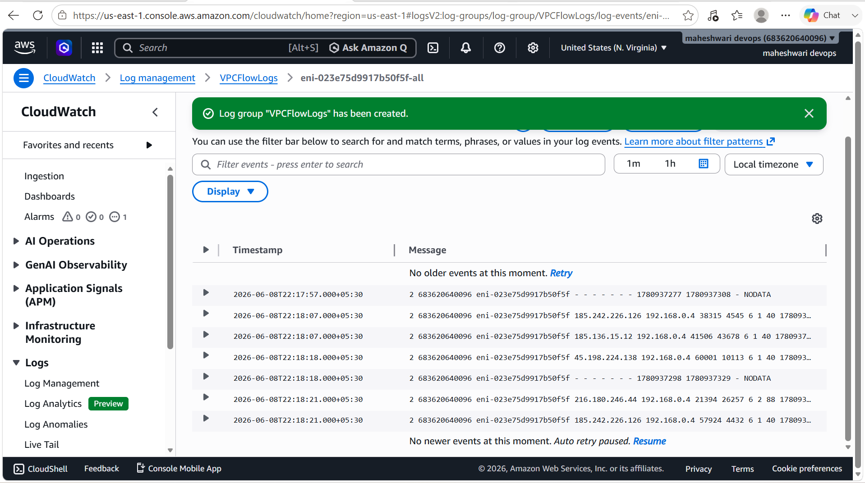

11. Create monitoring dashboards to monitor CPU utilization and to monitor the Apache service.

PURPOSE: To monitor EC2 instance performance and APACHE Web server availability using Amazon CloudWatch dashboards, helping detect performance issues and service outages.

OBJECTIVE: To monitor EC2 CPU utilization and also httpd service status. Create a CloudWatch dashboard displaying both metrics

STEP BY STEP IMPLEMENTATION:

- Download the cloudwatch agent and it will check and push logs to the cloudwatch
- Set cronjob for the logging.
- create a bash file with script for CPU utilization status, if value is 1 then alarm state will be OK and if the value is 0 then alarm state will be IN-ALARM state.
- This will be acheived by created dashboards and alarms in CloudWatch.

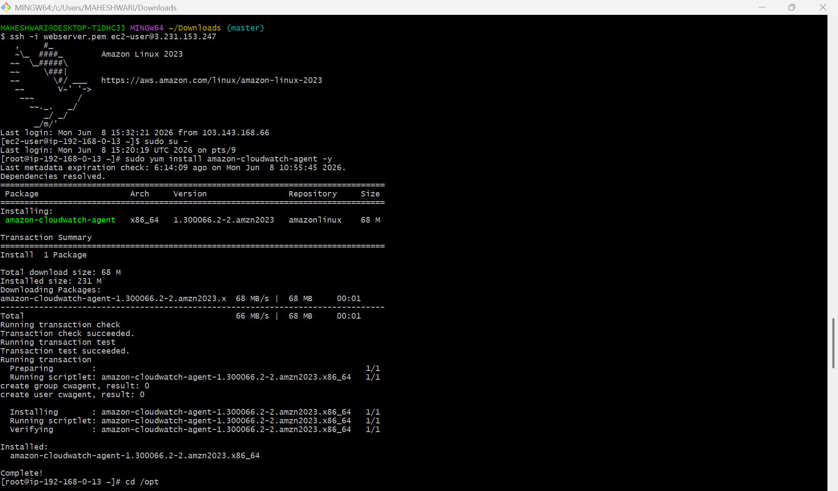

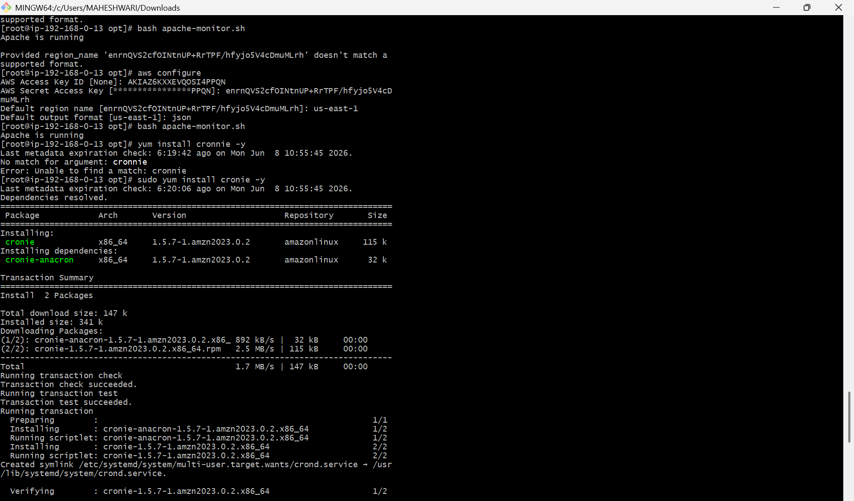

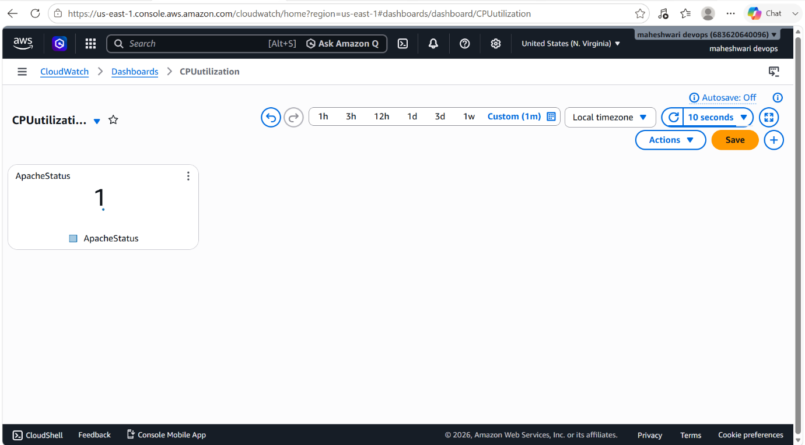

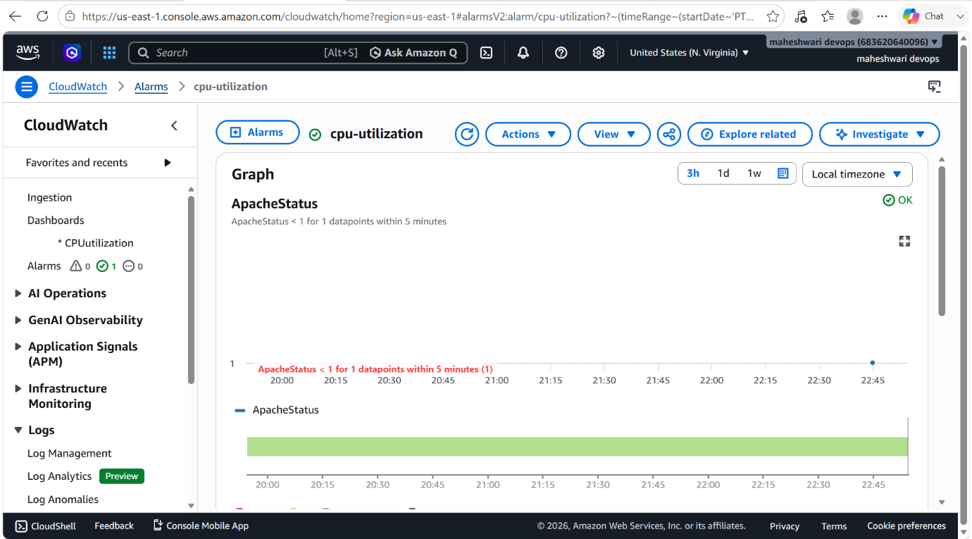

12. If CPU utilization is more than 70%, then it should trigger auto scaling and launch new instance.

PURPOSE: Automatically increase the number of EC2 instances when CPU usage becomes high, ensuring application availability and performance during increases load.

STEP BY STEP IMPLEMENTATION:

- Create a launch template first that you want to what type of instance should be launched when the autoscaling is triggered.

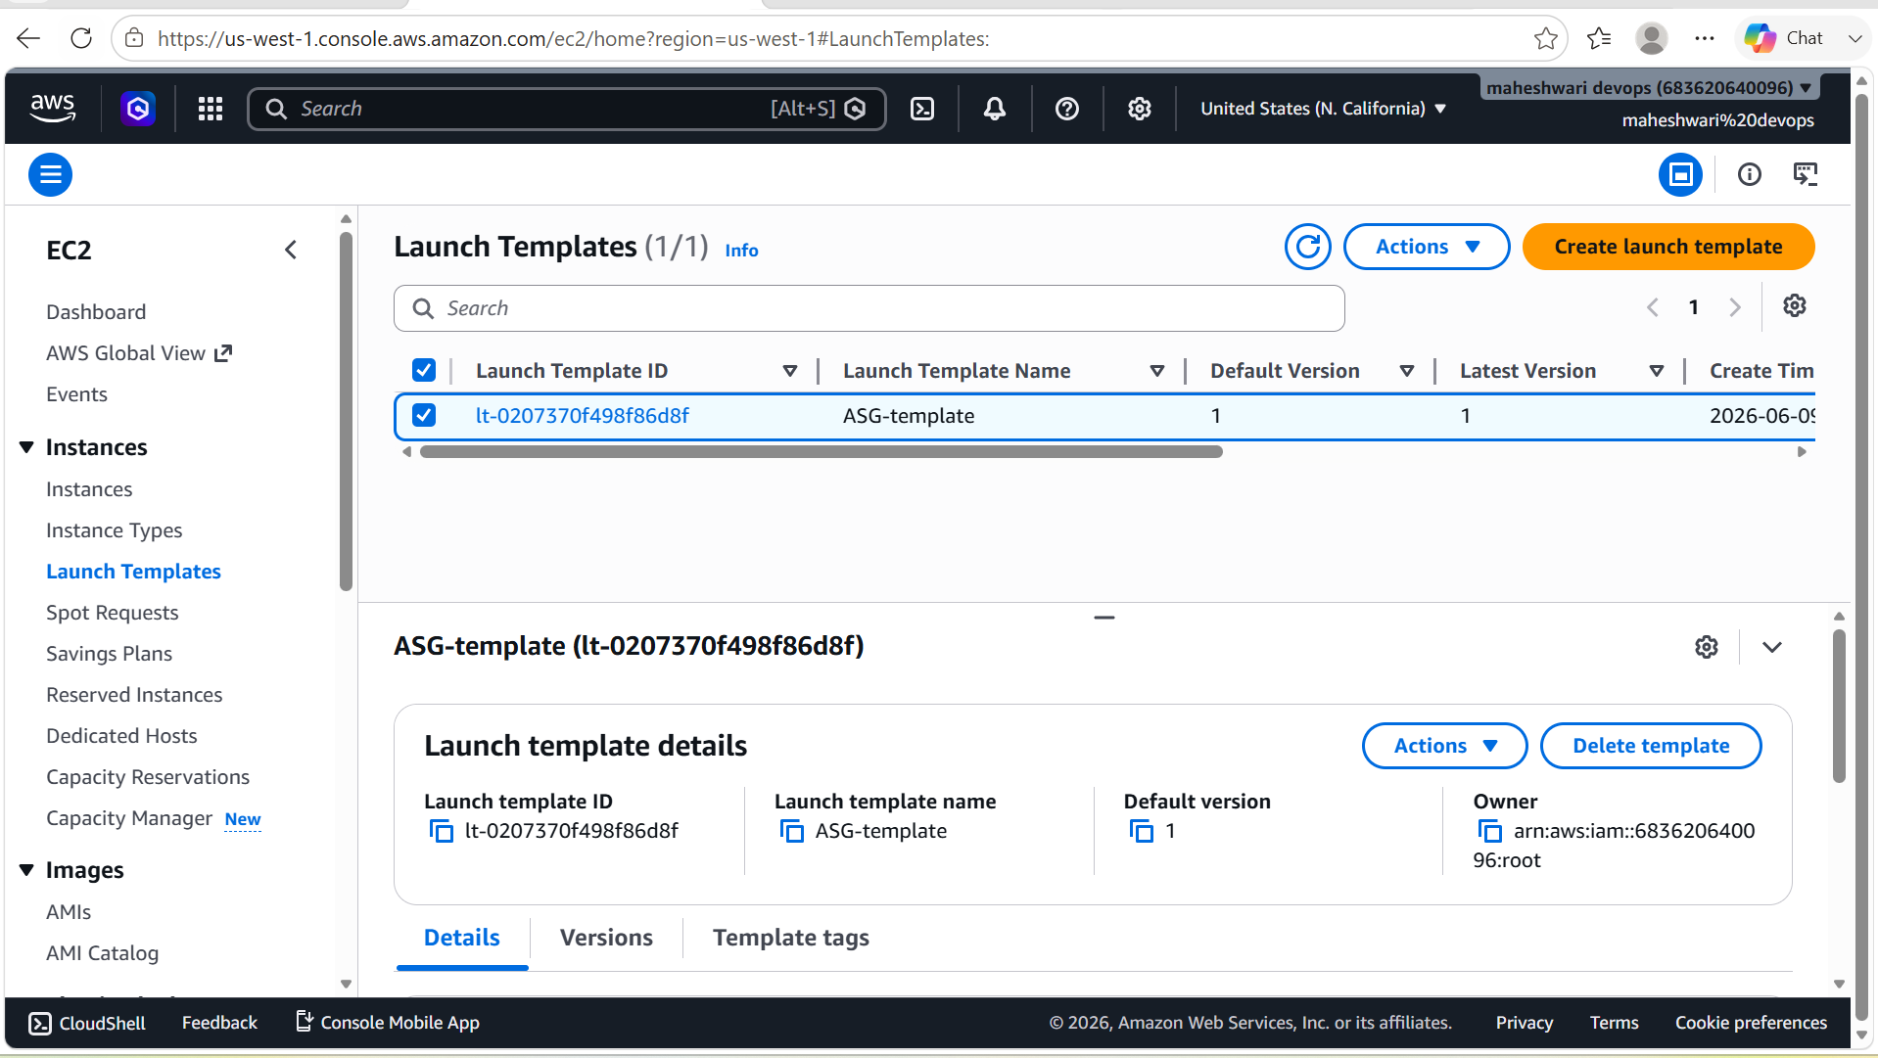

- In the navigation pane of EC2, go to autoscaling groups and that’s where create a new auto scaling group.
- In that we have do dynamic autoscaling so that when the CPU utilization of our instance is more than 70%.
- Then it should launch a new instance using the launch template.

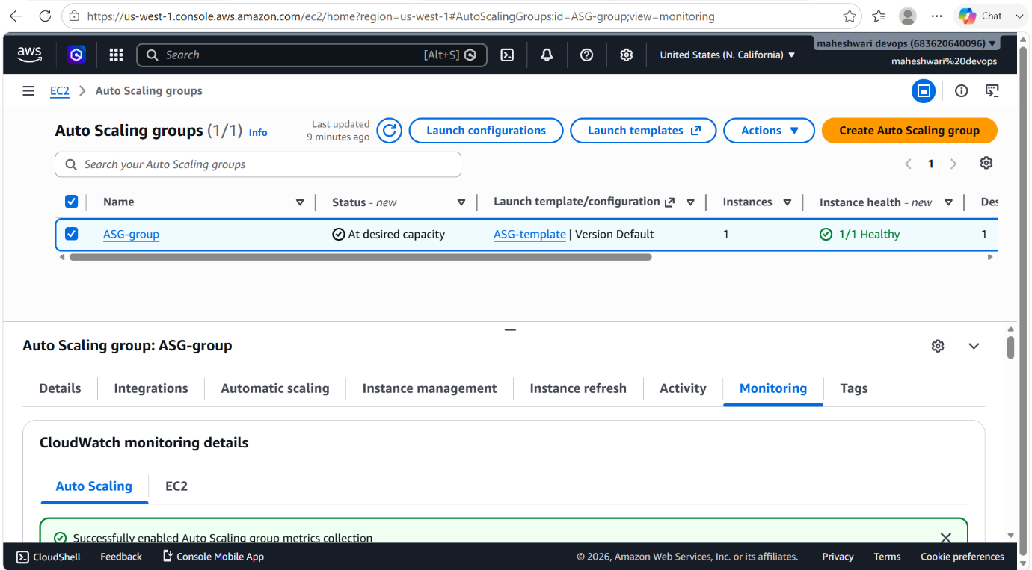

- To verify our autoscaling group is working as per the requirement.
- It will create a new instance.

